

**NETWORK SCIENCE PROJECT**

**ALL OUTPUTS REPORT FOR ANALYSIS**

**MOTIVATION:**

**How does gender inequality manifest in the workplace, and what contributing factors can be identified through a case study analysis, aiming to understand the challenges and dynamics surrounding this issue?**

**CONTRIBUTORS:**

**ÖMER CEM TABAR - 2081169**

**ANIL ÖZFIRAT - 2087154**

**İSMAİL DEHA KÖSE - 2072544**

**ZAFER ÇINAR - 2041428**

**INSTRUCTOR:**

**TOMASO ERSEGHE**

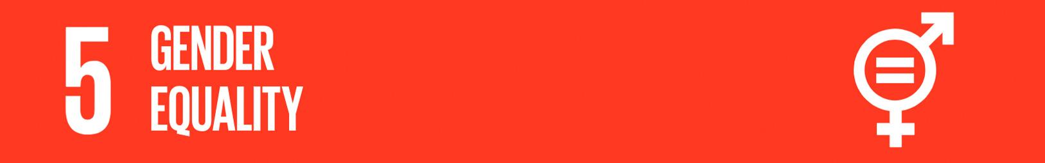

1. **CONSIDERED KEYWORDS FOR SUBREDDIT & POSTS ANALYSIS**
   1. **Package 1:** 
      1. **Subreddit Analysis Keywords: Woman AND Inequality**
      2. **Post Analysis Keywords: job OR work OR workplace OR office OR company OR industry**
   2. **Package 2:**
      1. **Subreddit Analysis Keywords: Women AND Inequality**
      2. **Post Analysis Keywords: job OR work OR workplace OR office OR company OR industry**
   3. **Package 3:** 
      1. **Subreddit Analysis Keywords: Female AND Inequality**
      2. **Post Analysis Keywords: job OR work OR workplace OR office OR company OR industry**
   4. **Package 4: (Combined Package 1 and Package 2)**
   5. **Package 5: (Combined Package 2 and Package 3)**
   6. **Package 6: (Combined Package 1 and Package 3)**
   7. **Package 7: (Combined Package 1, Package 2 and Package 3)**
2. **PERFORMANCE METRICS FOR CONSIDERED ANALYSIS PACKAGES**
   1. **Package 1:**

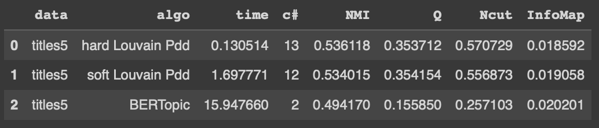 

* 1. **Package 2:**

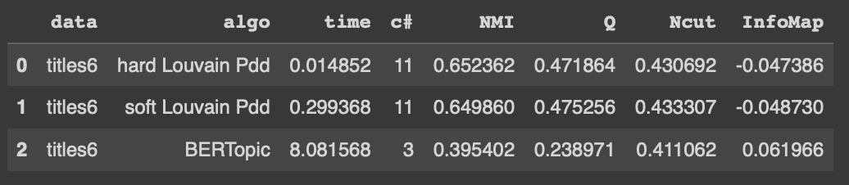 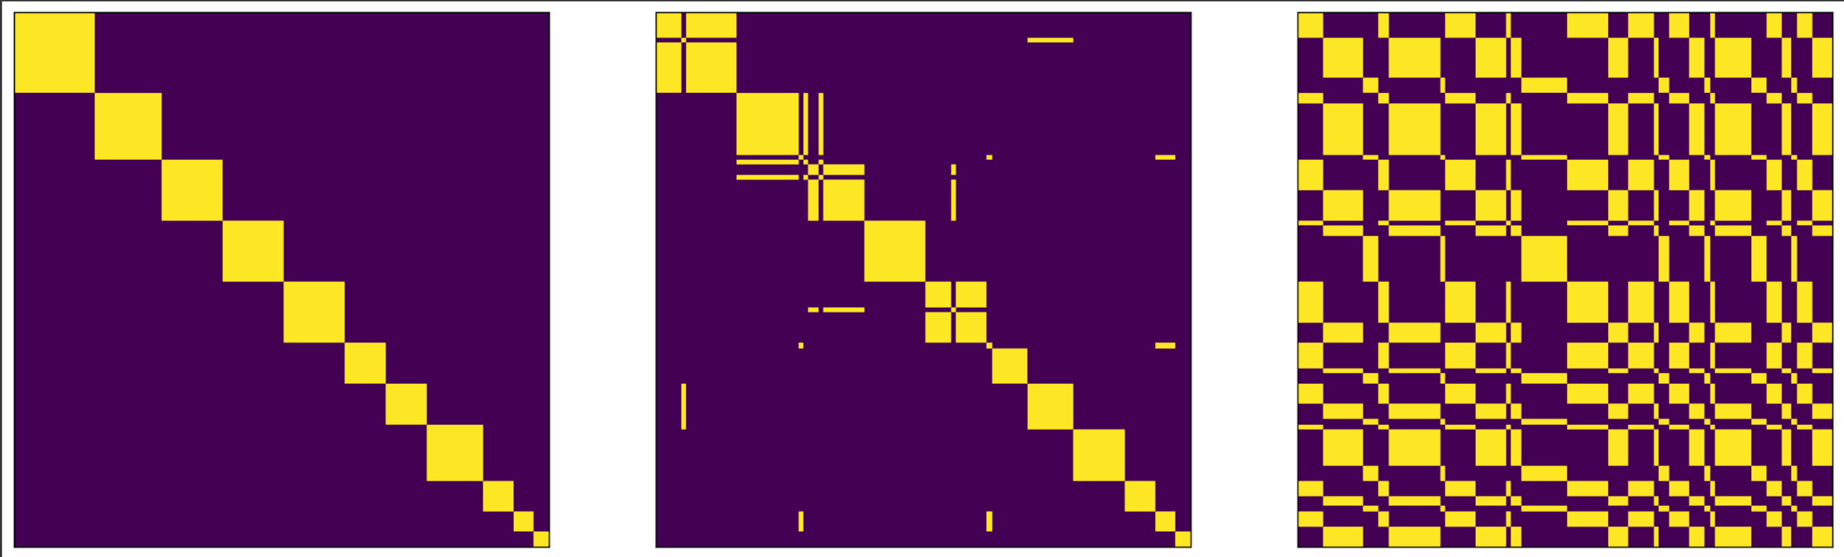

* 1. **Package 3:**

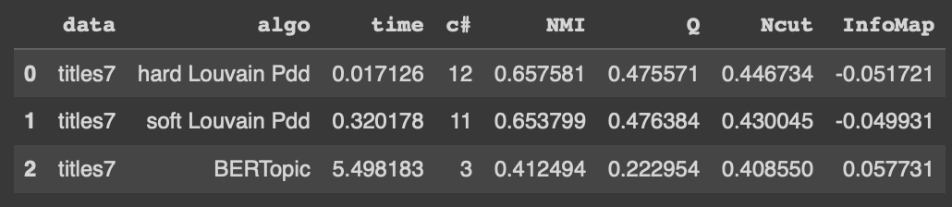 

* 1. **Package 4:**

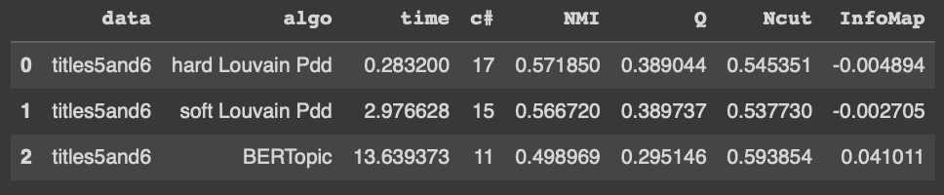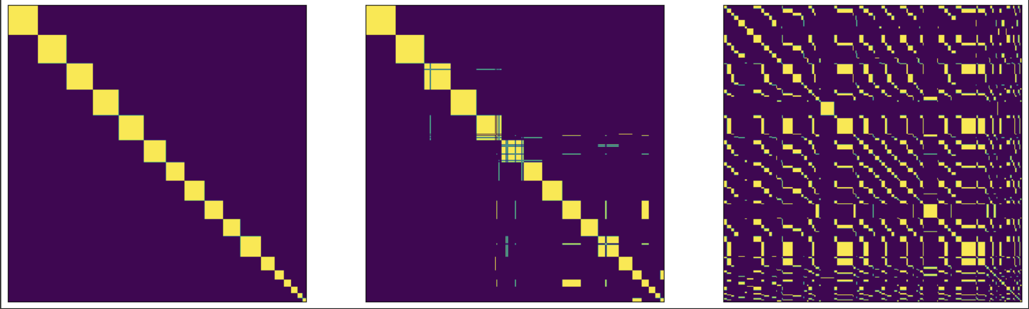

* 1. **Package 5:**

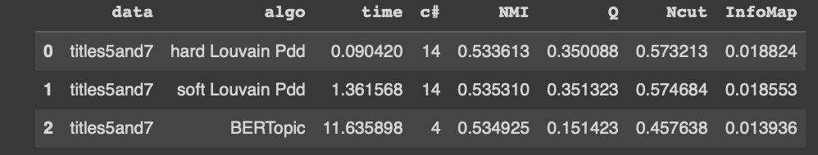

* 1. **Package 6:**

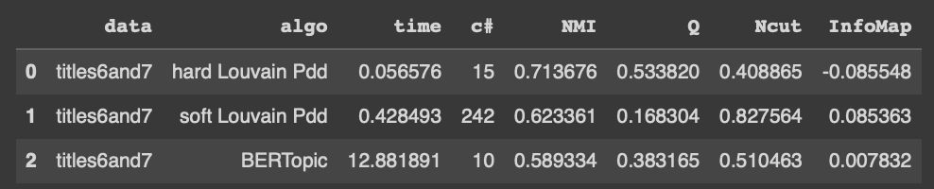 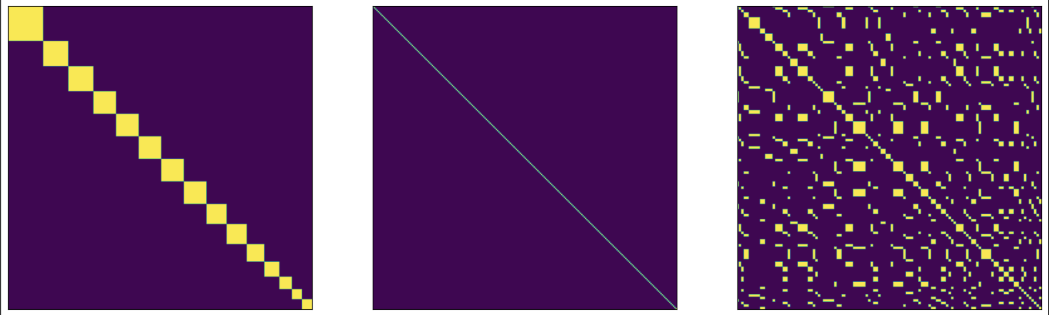

* 1. **Package 7:**

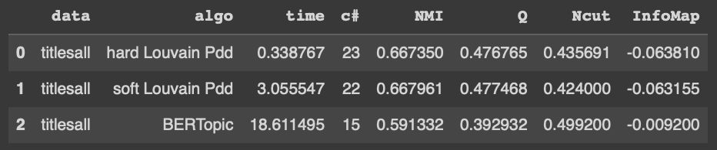 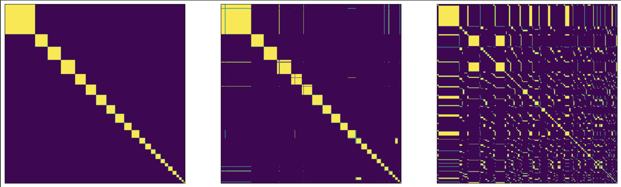

1. **DETECTED TOPICS FOR ANALYSIS PACKAGES**
   1. **Package 1:**

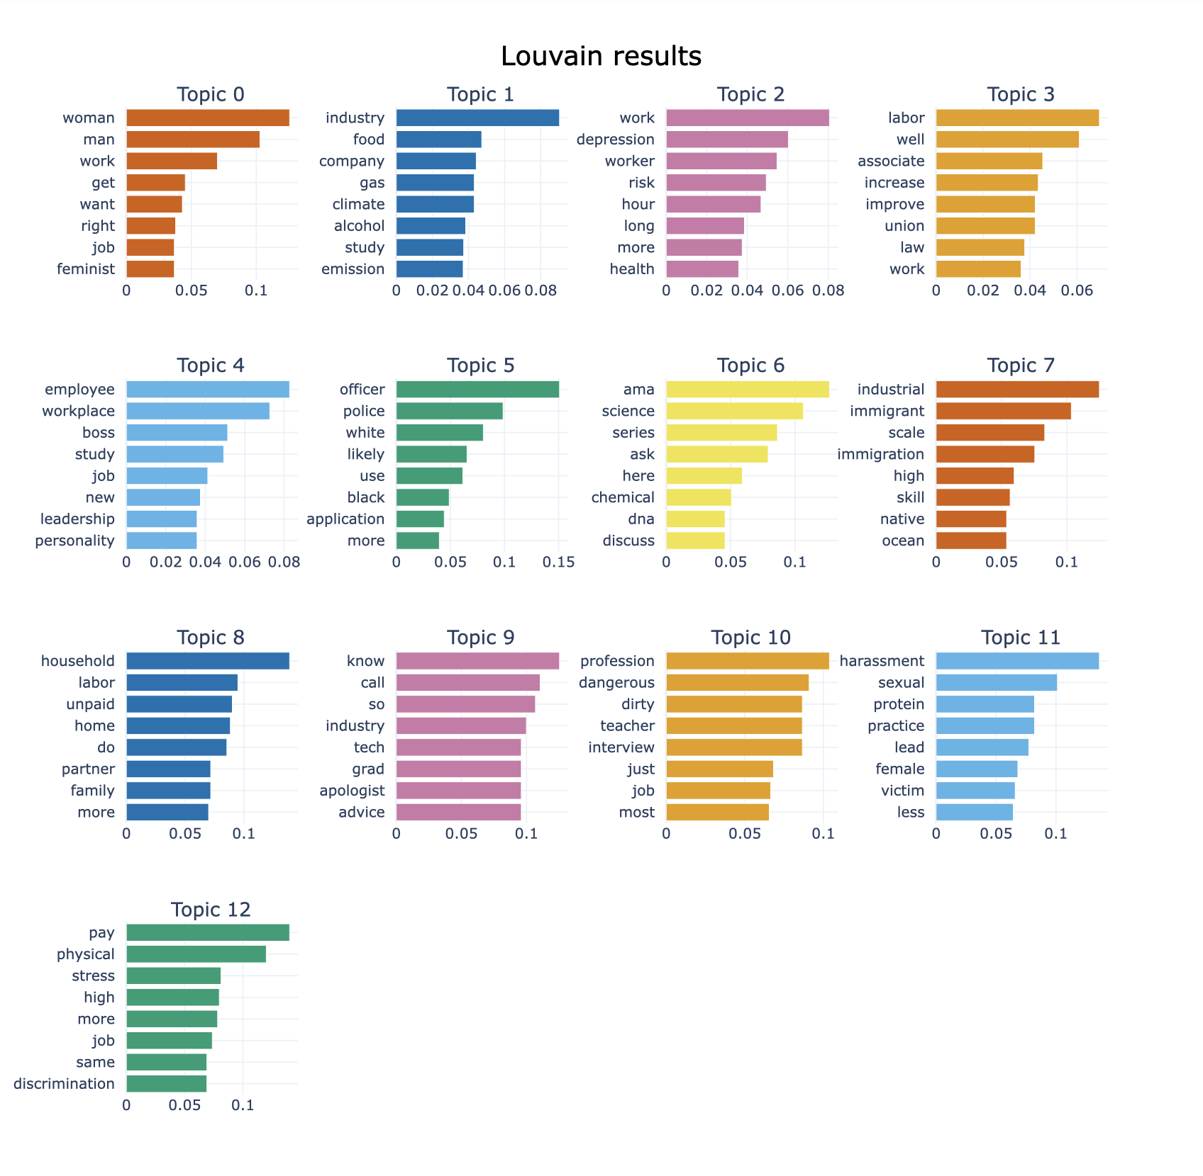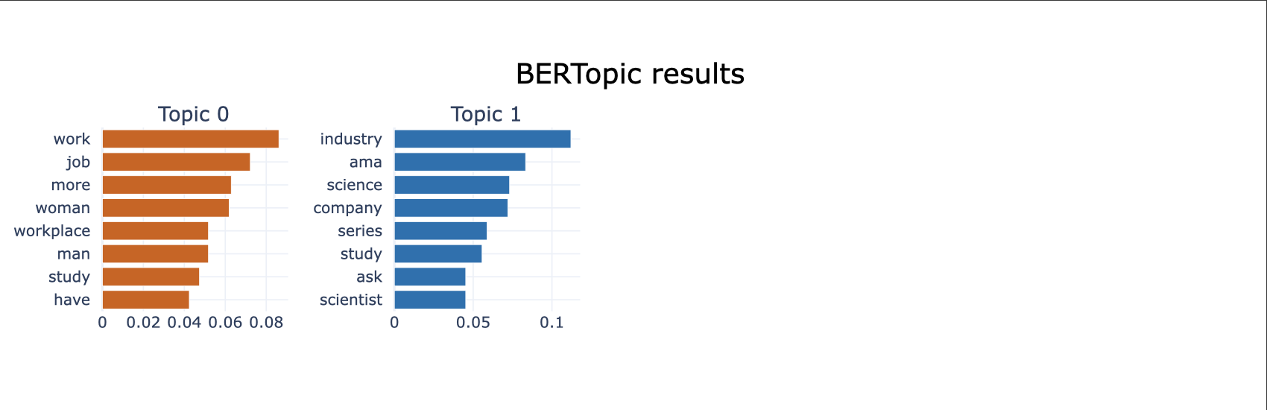

* 1. **Package 2:**

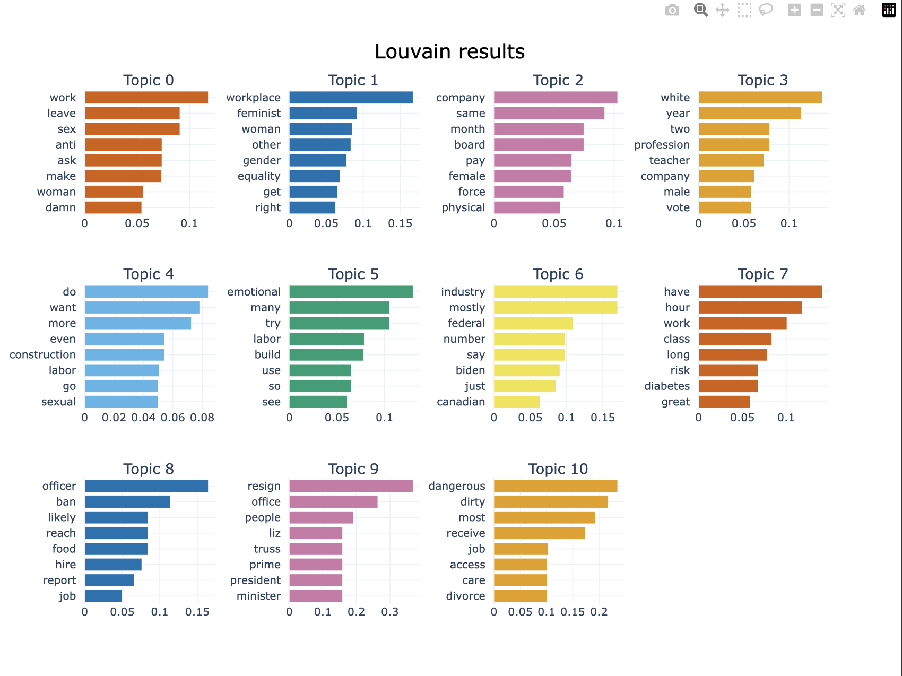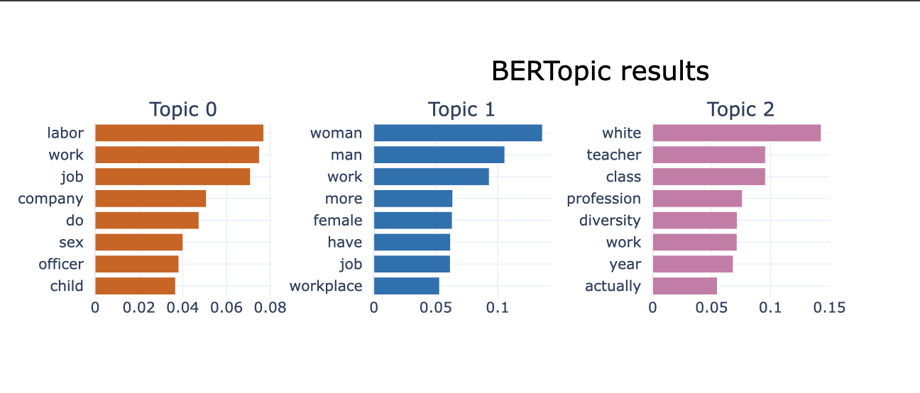

* 1. **Package 3:**

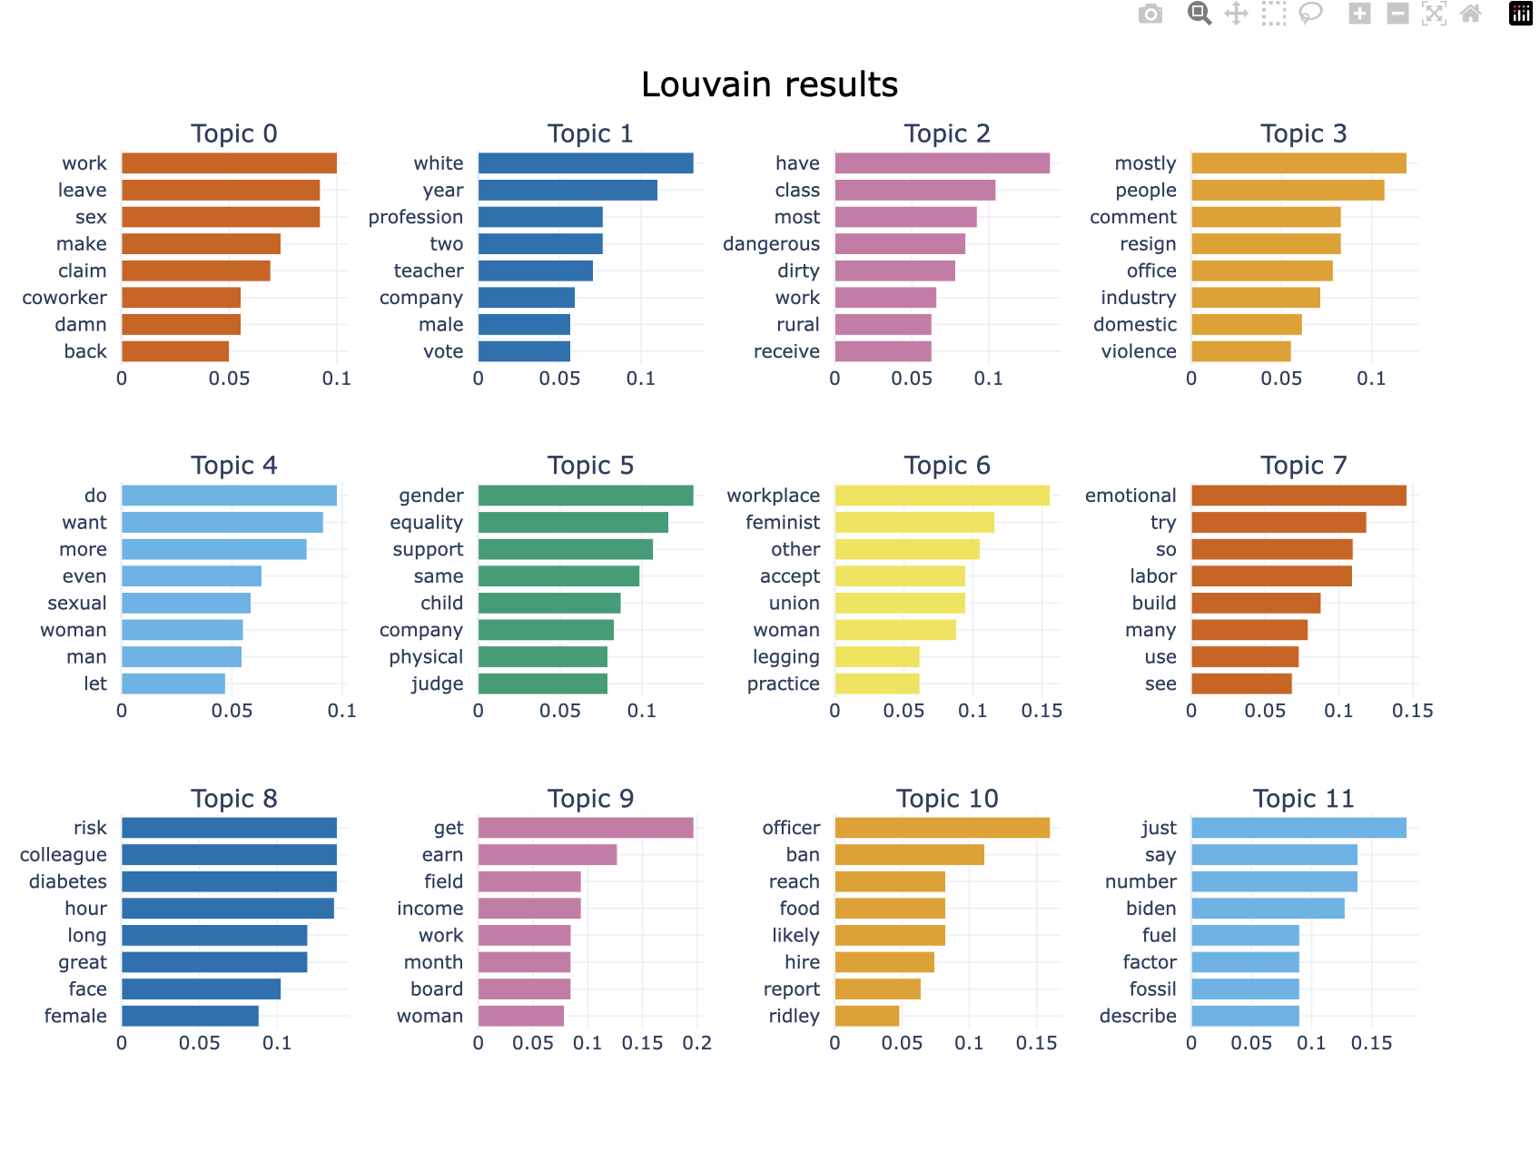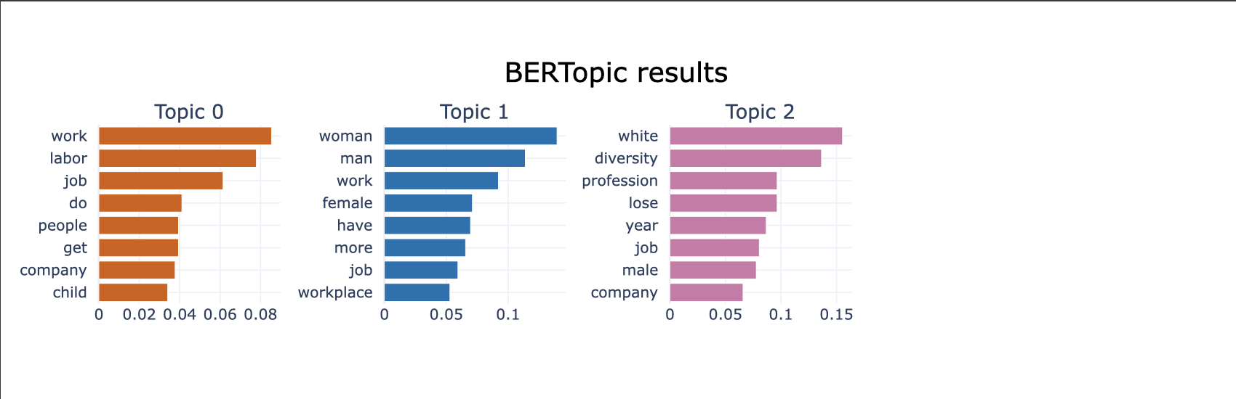

* 1. **Package 4:**

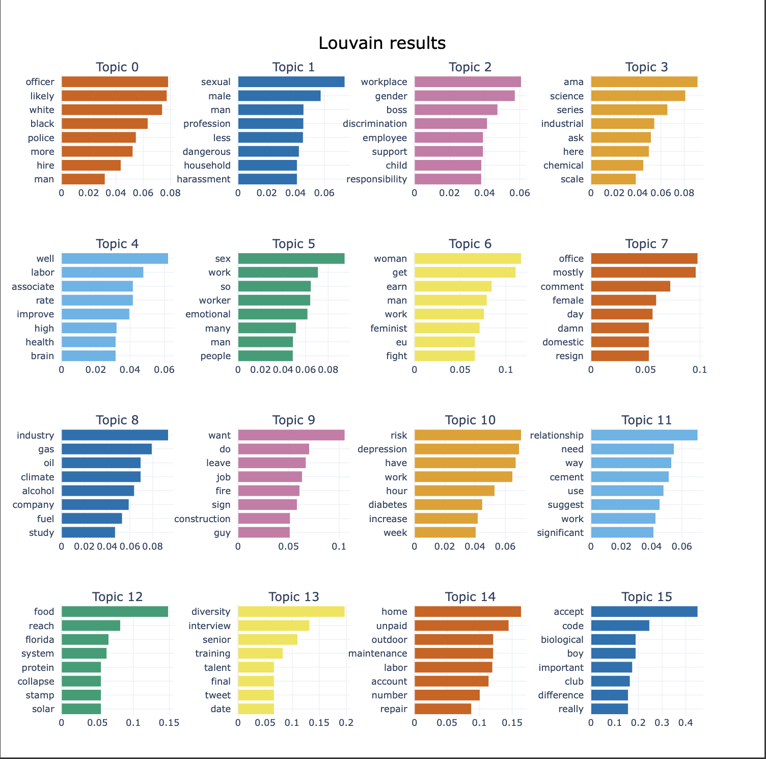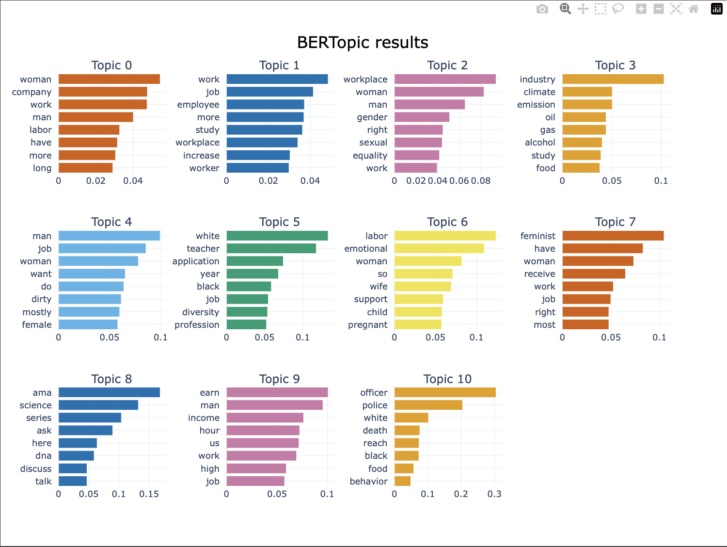

* 1. **Package 5:**

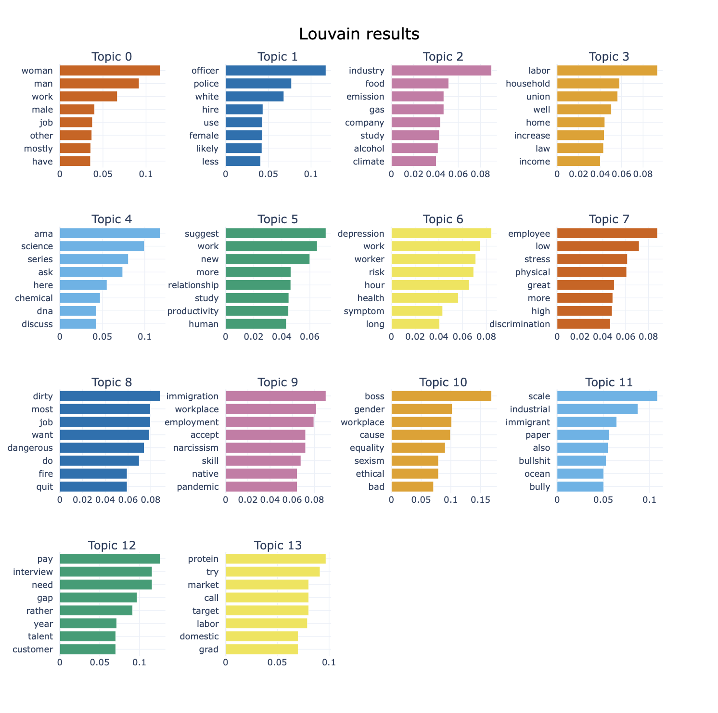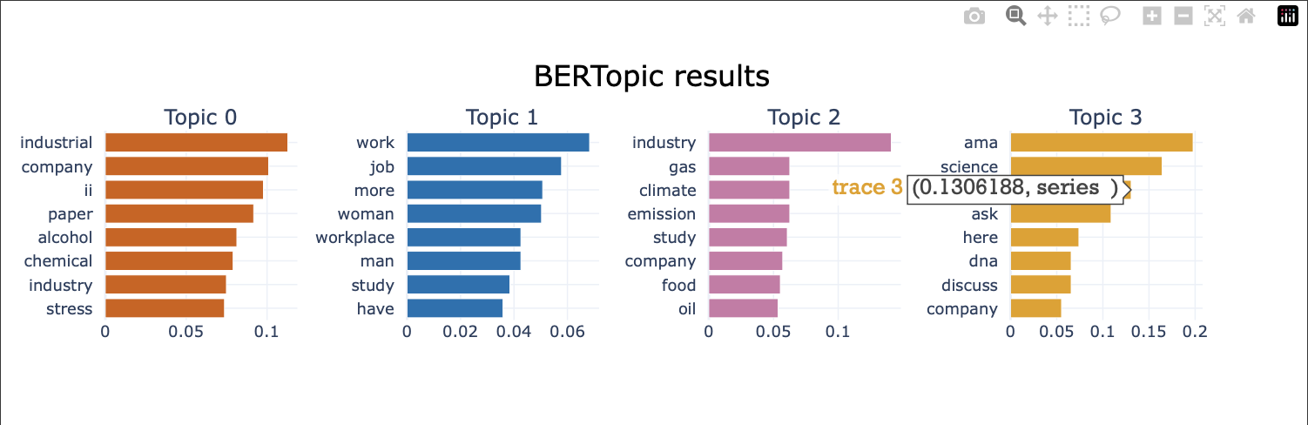

* 1. **Package 6:**

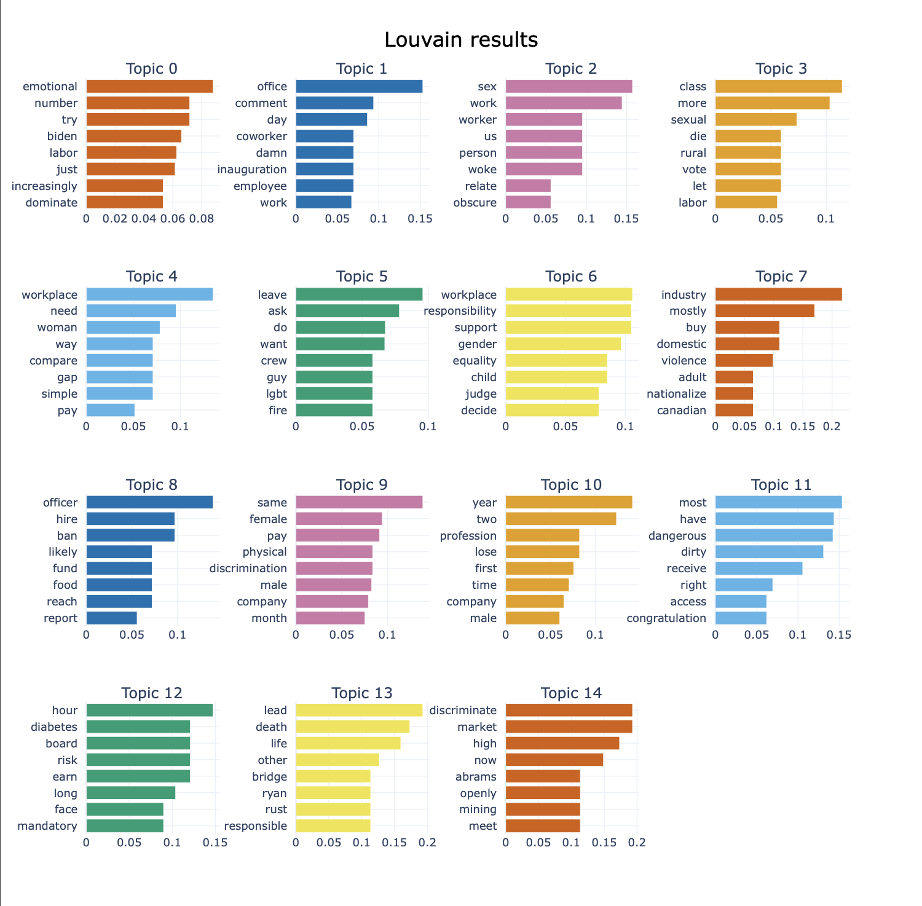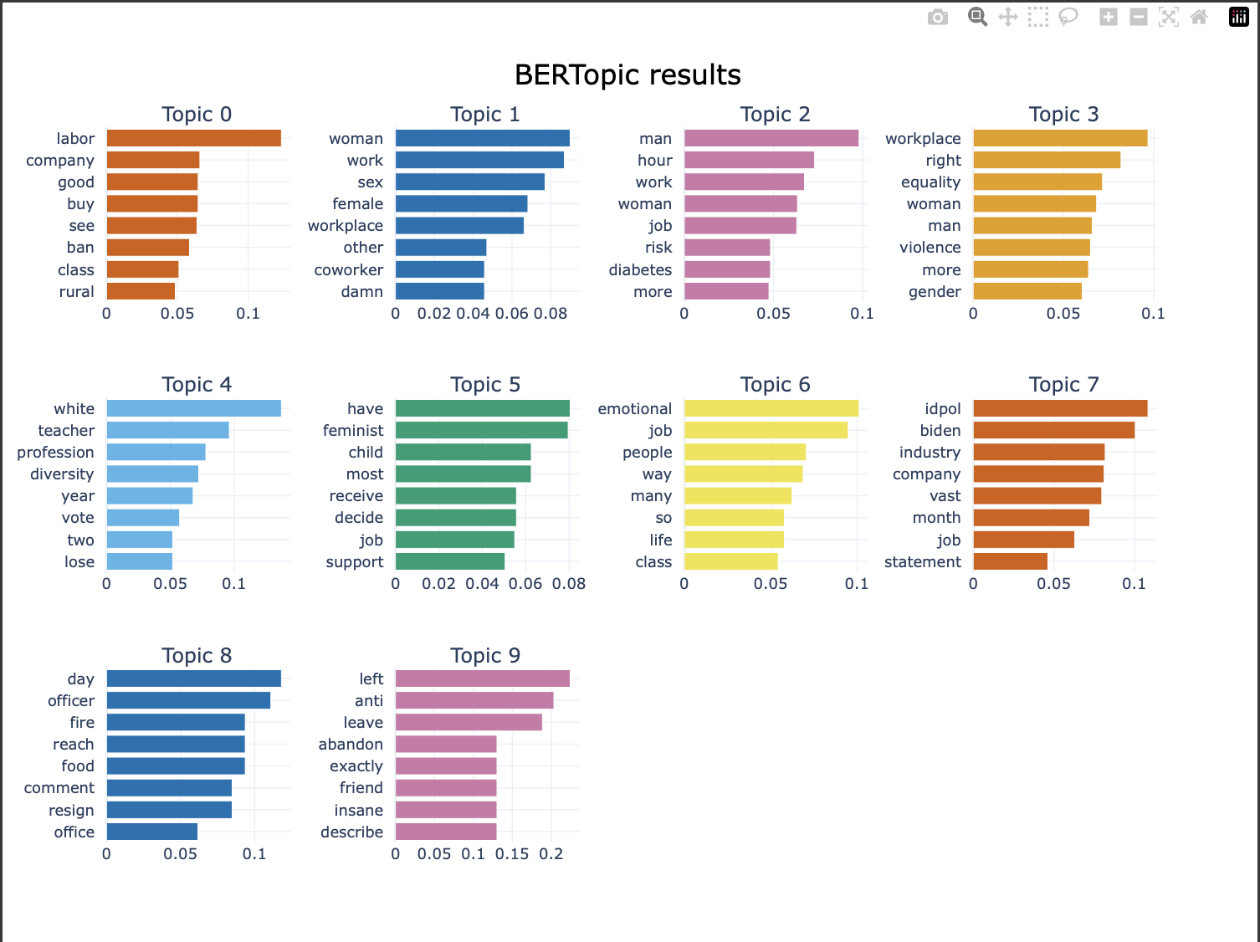

* 1. **Package 7:**

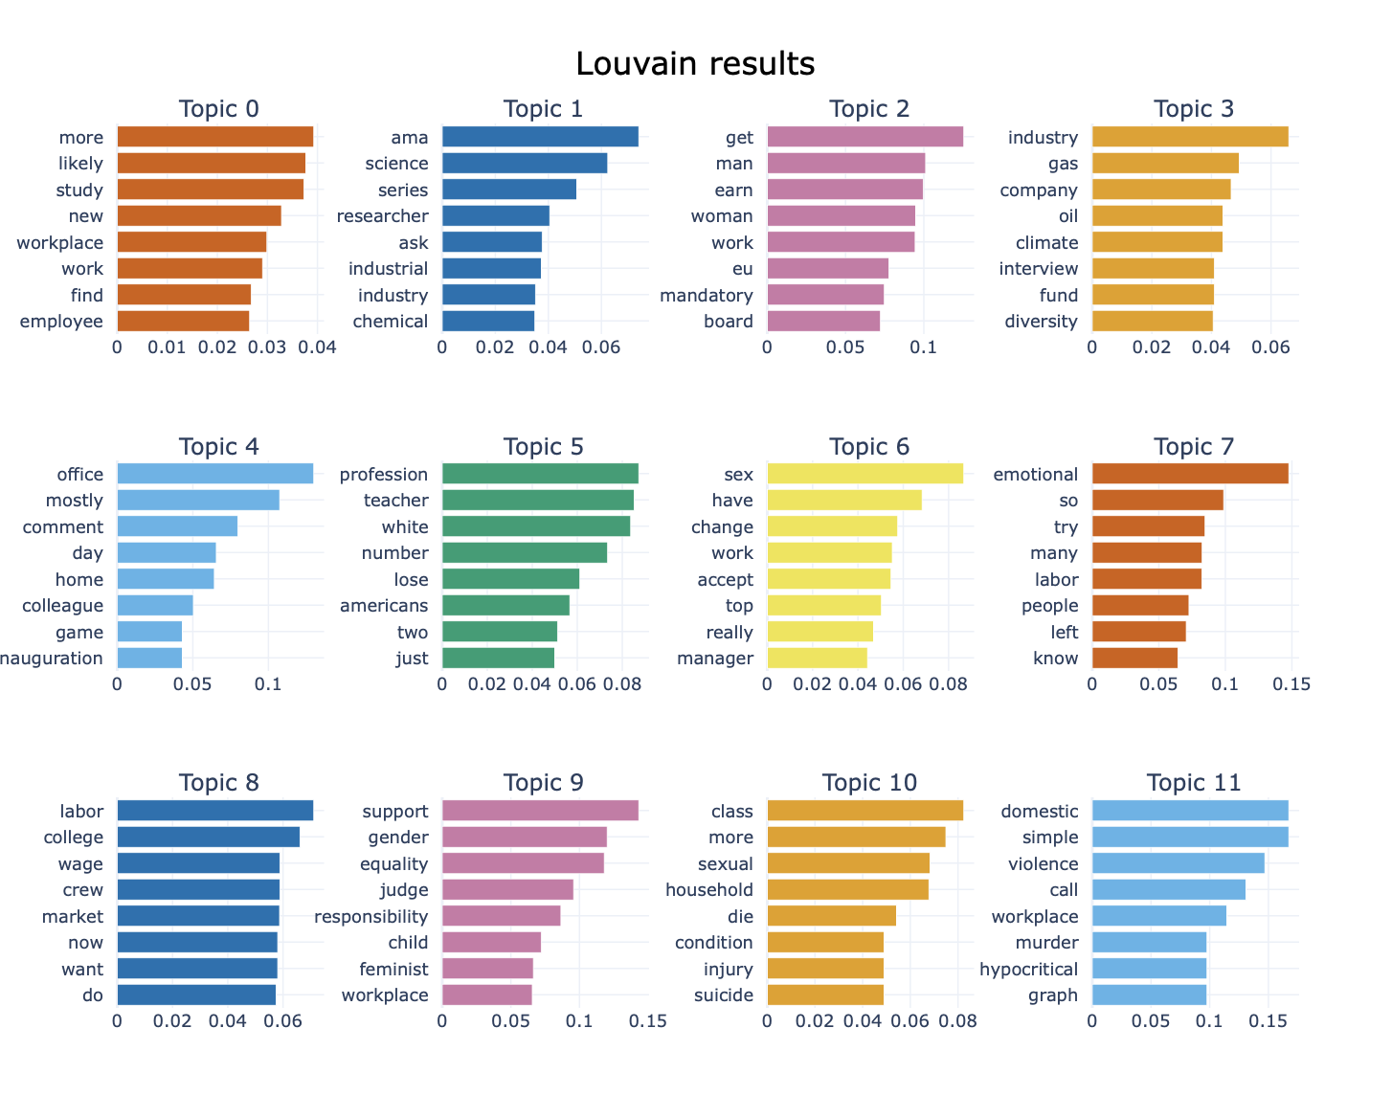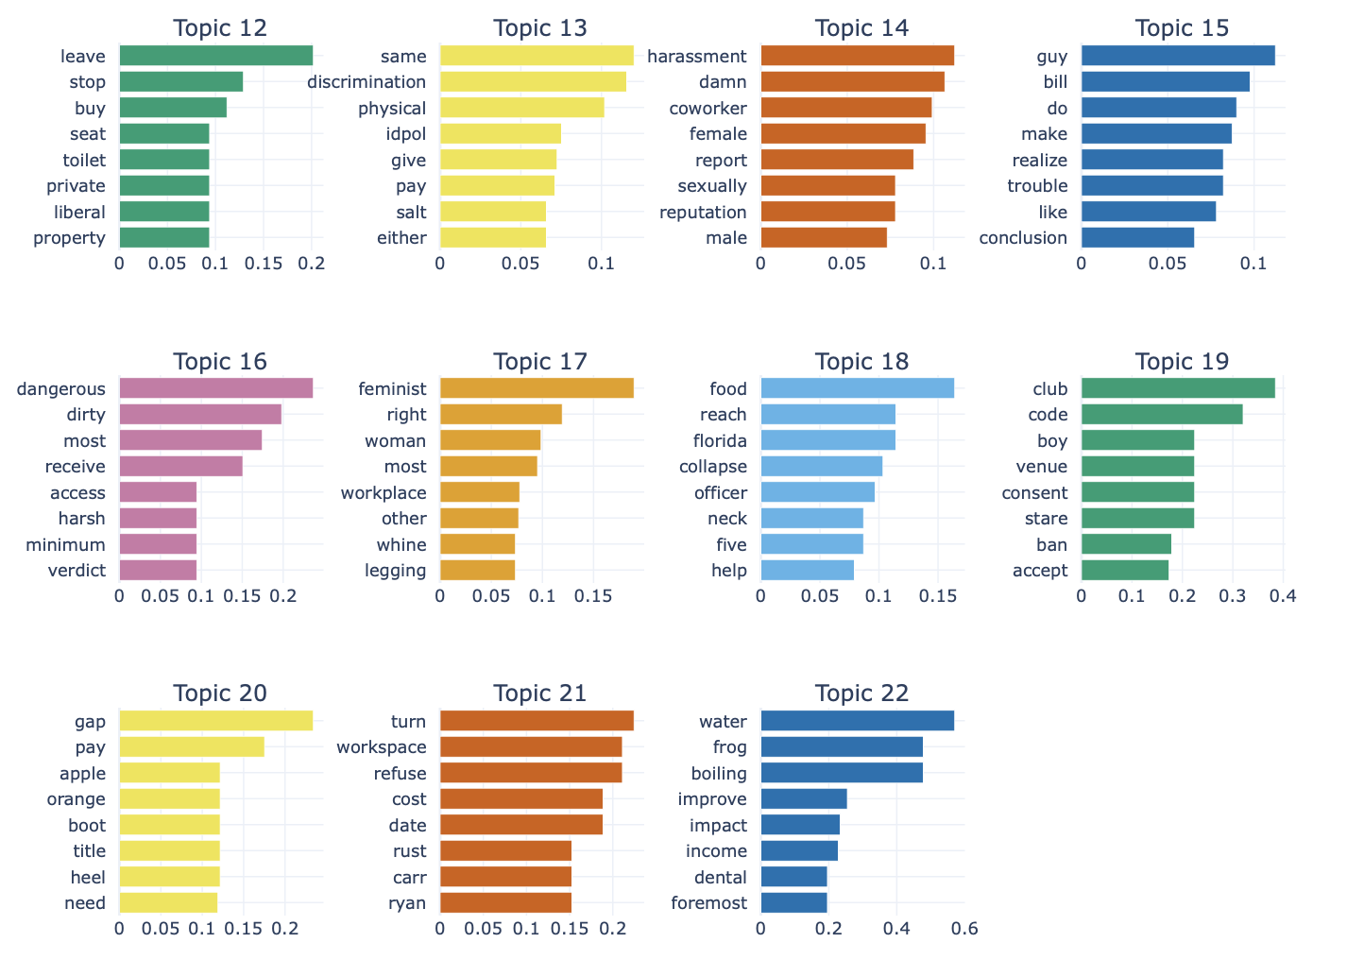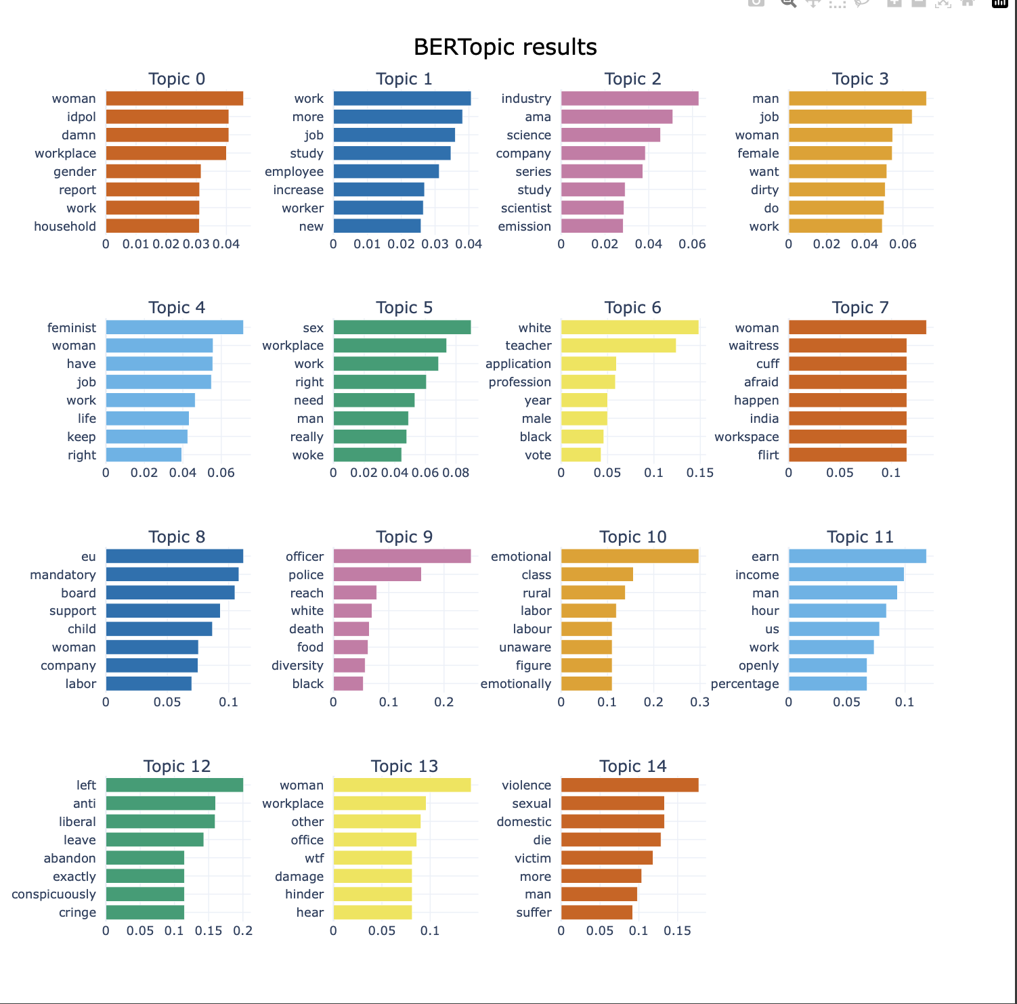

1. **CONSTRUCTED WORD CLOUDS FROM ANALYSIS PACKAGES**
   1. **Package 1:**

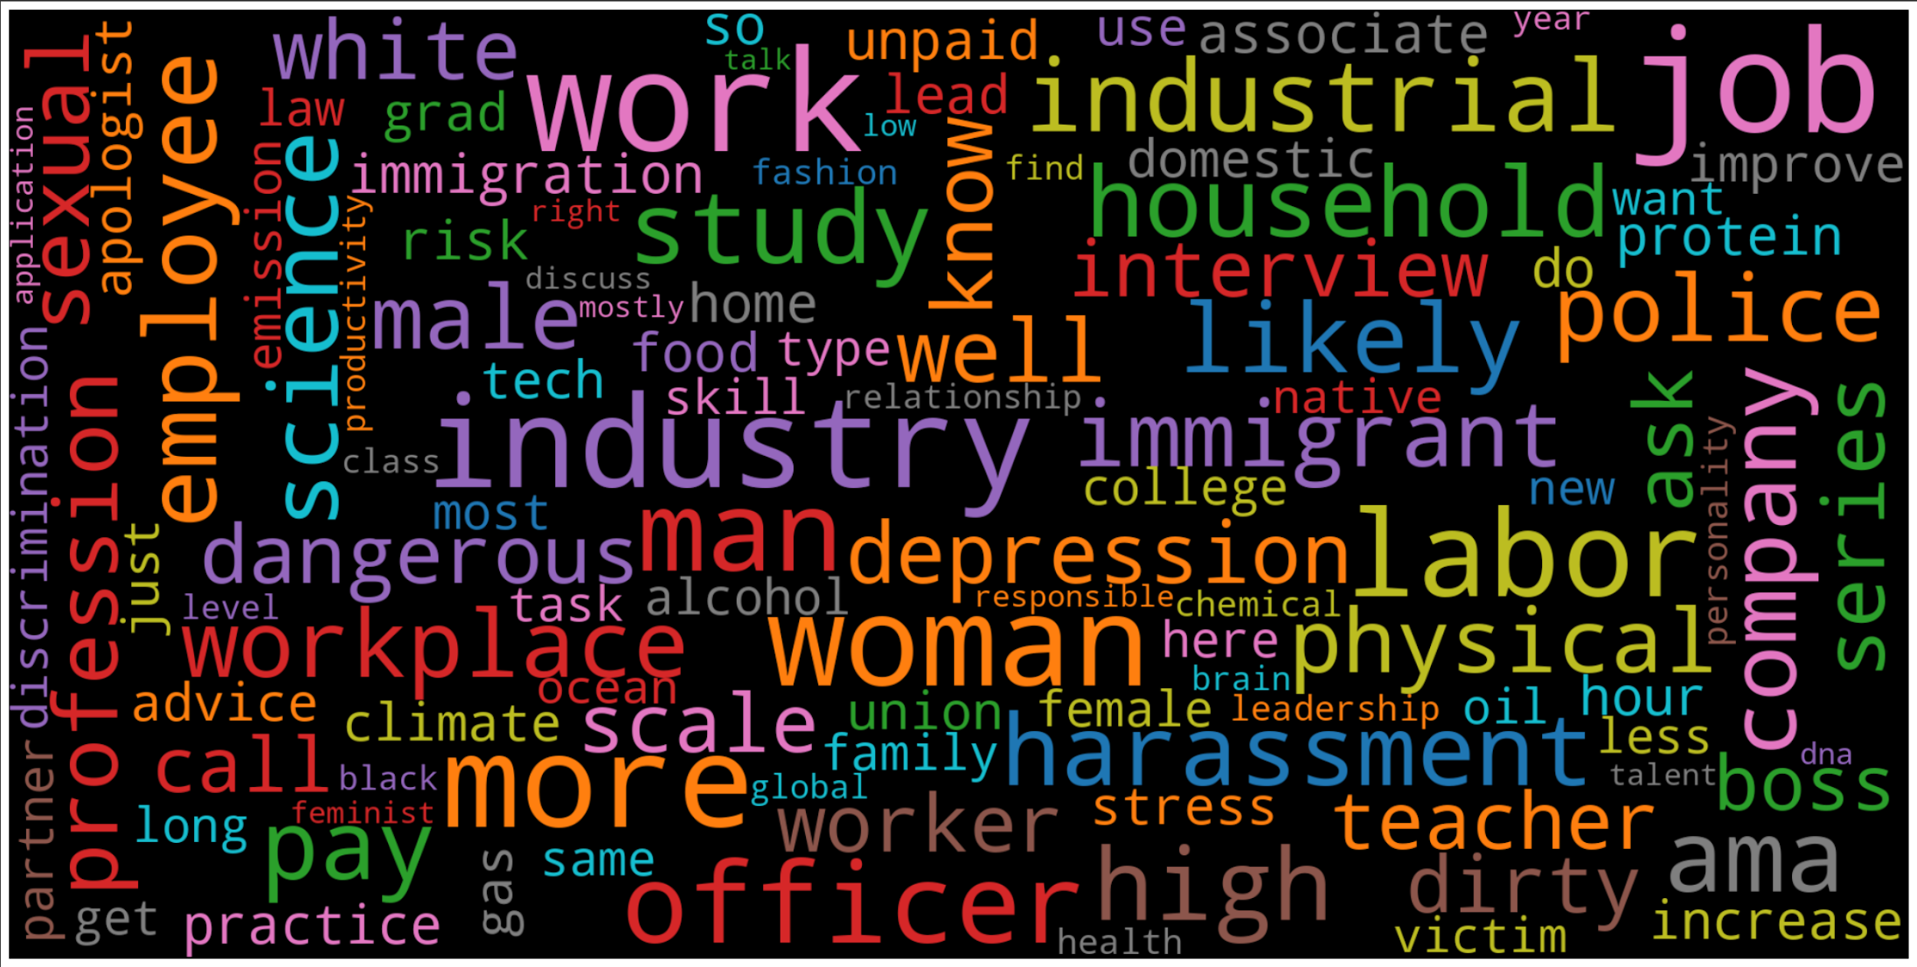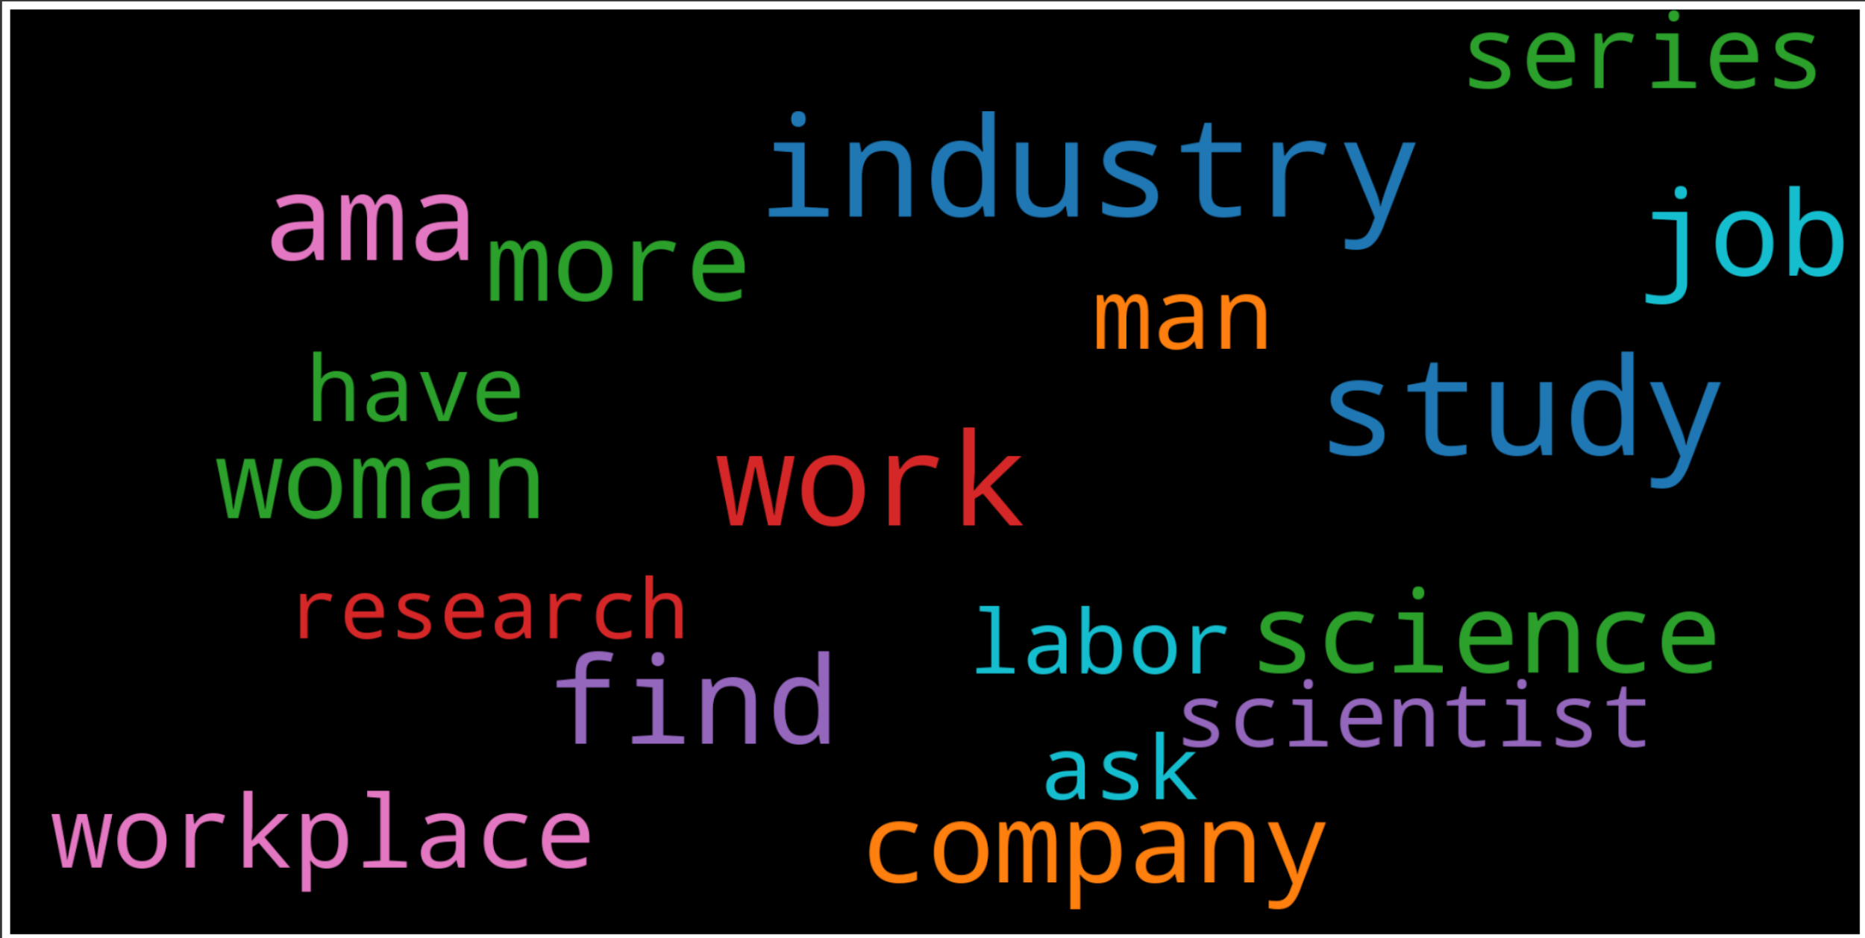

* 1. **Package 2:**

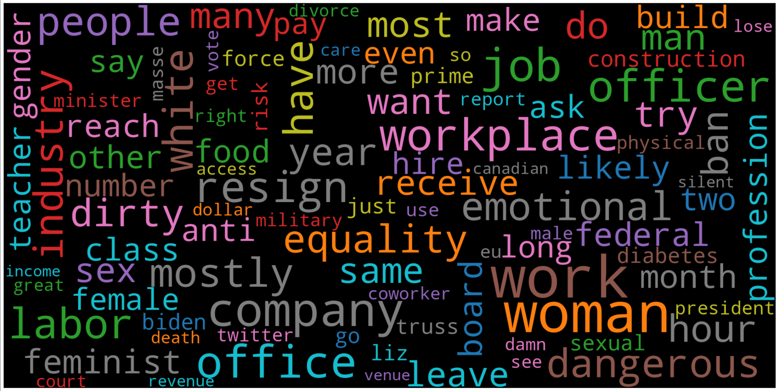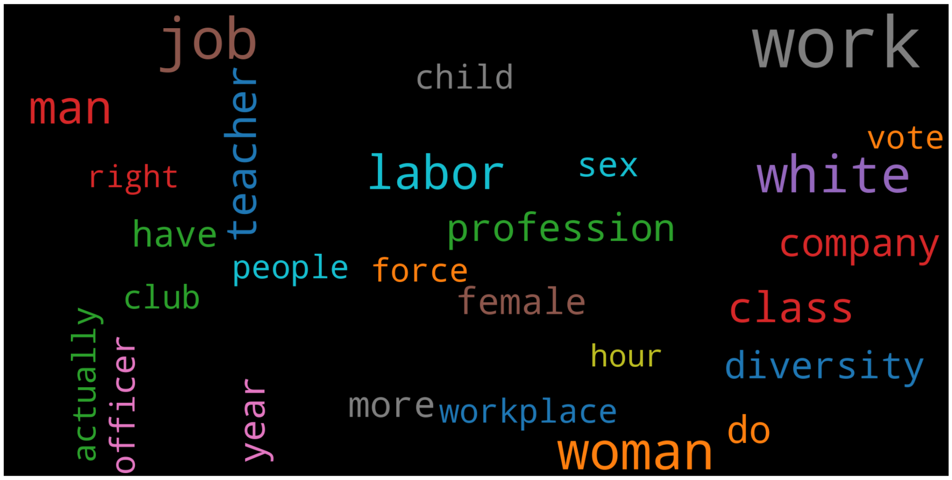

* 1. **Package 3:**

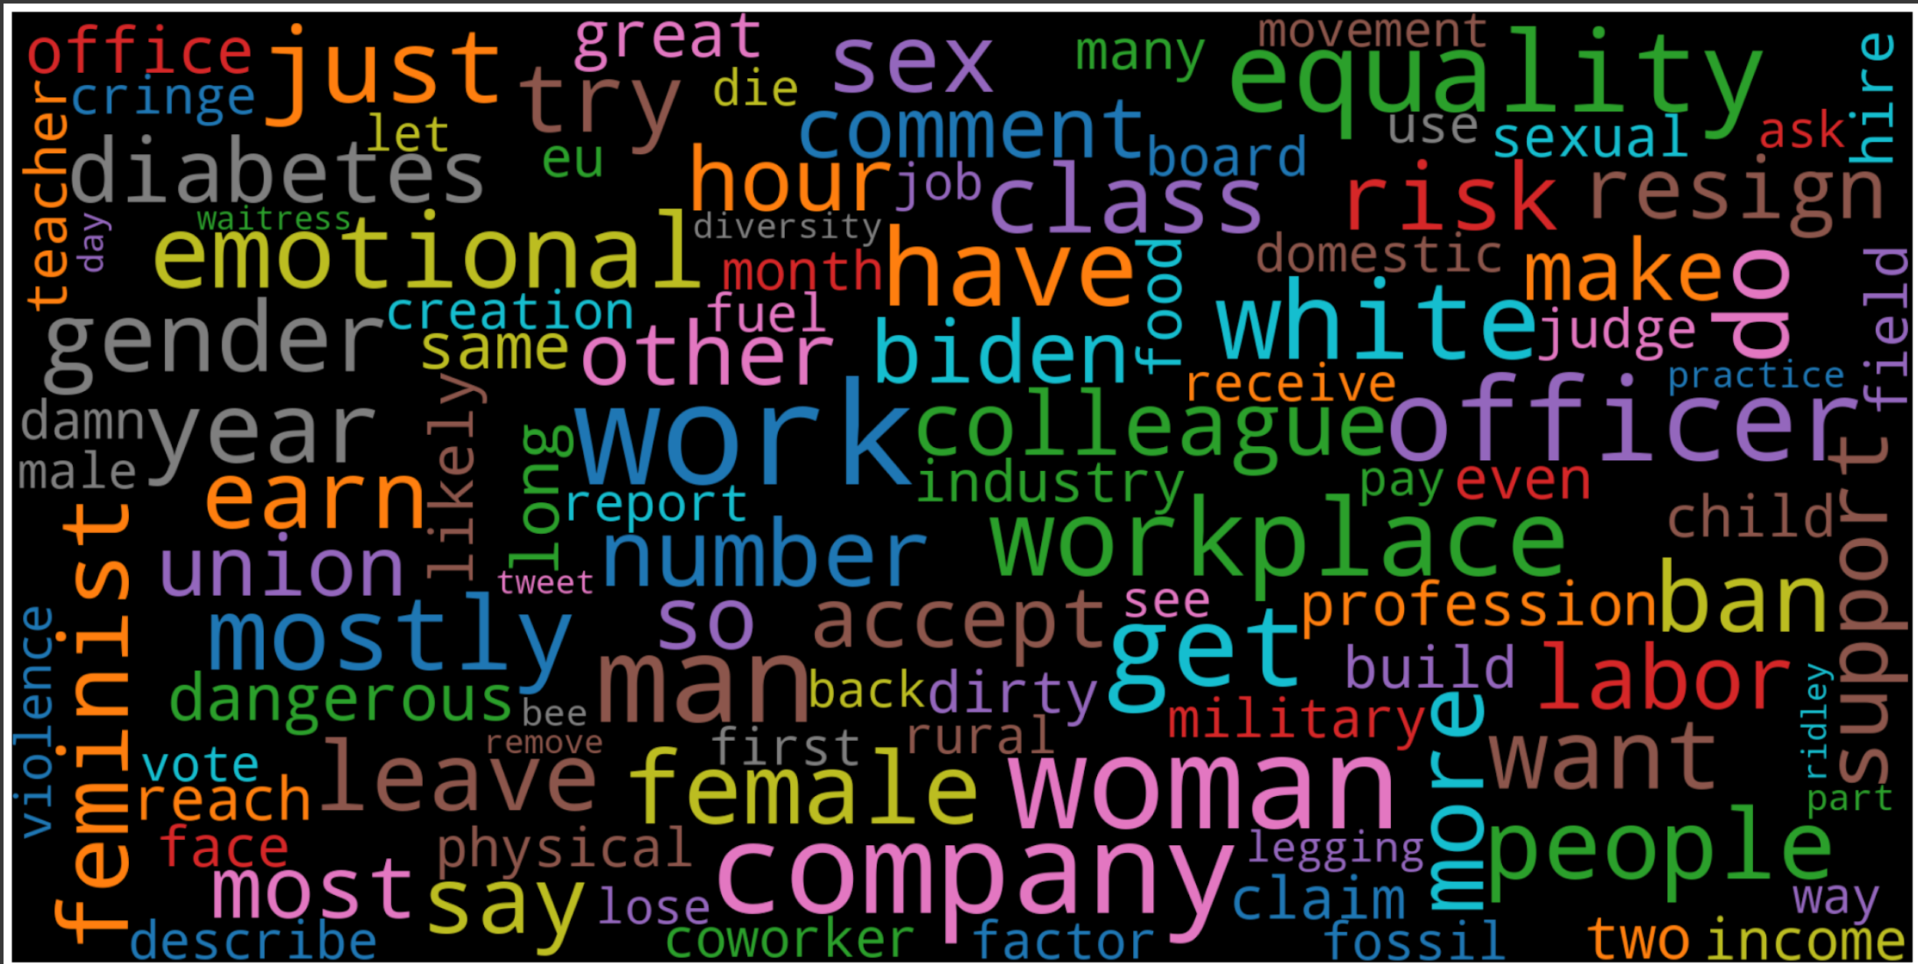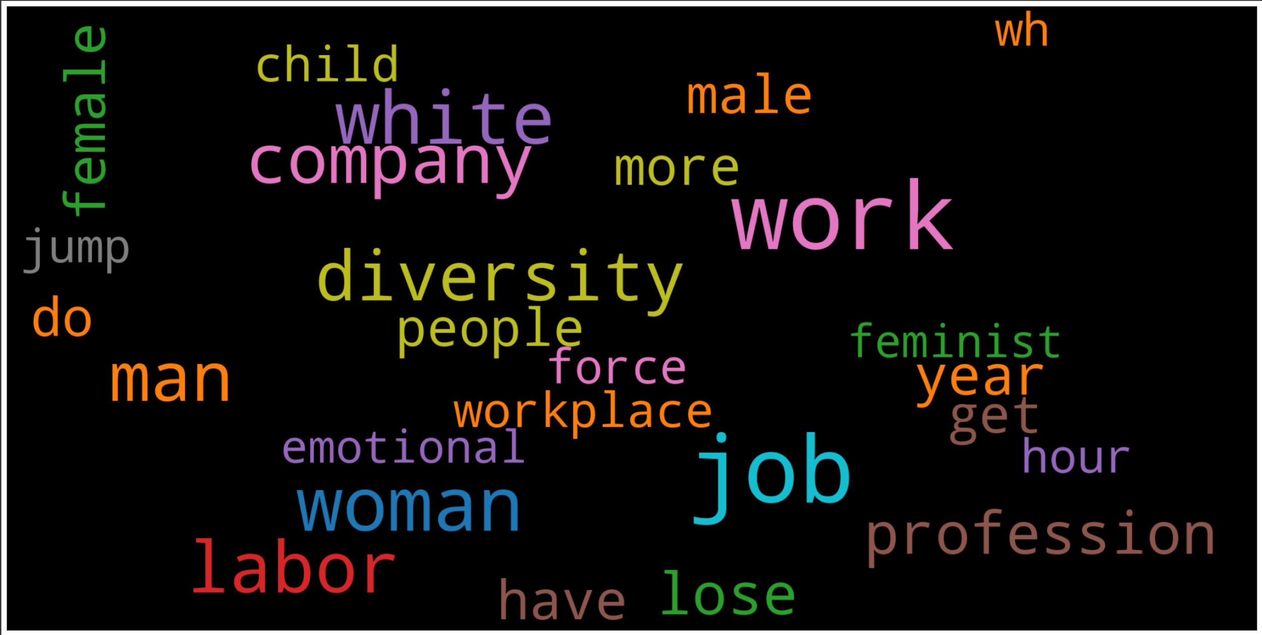

* 1. **Package 4:**

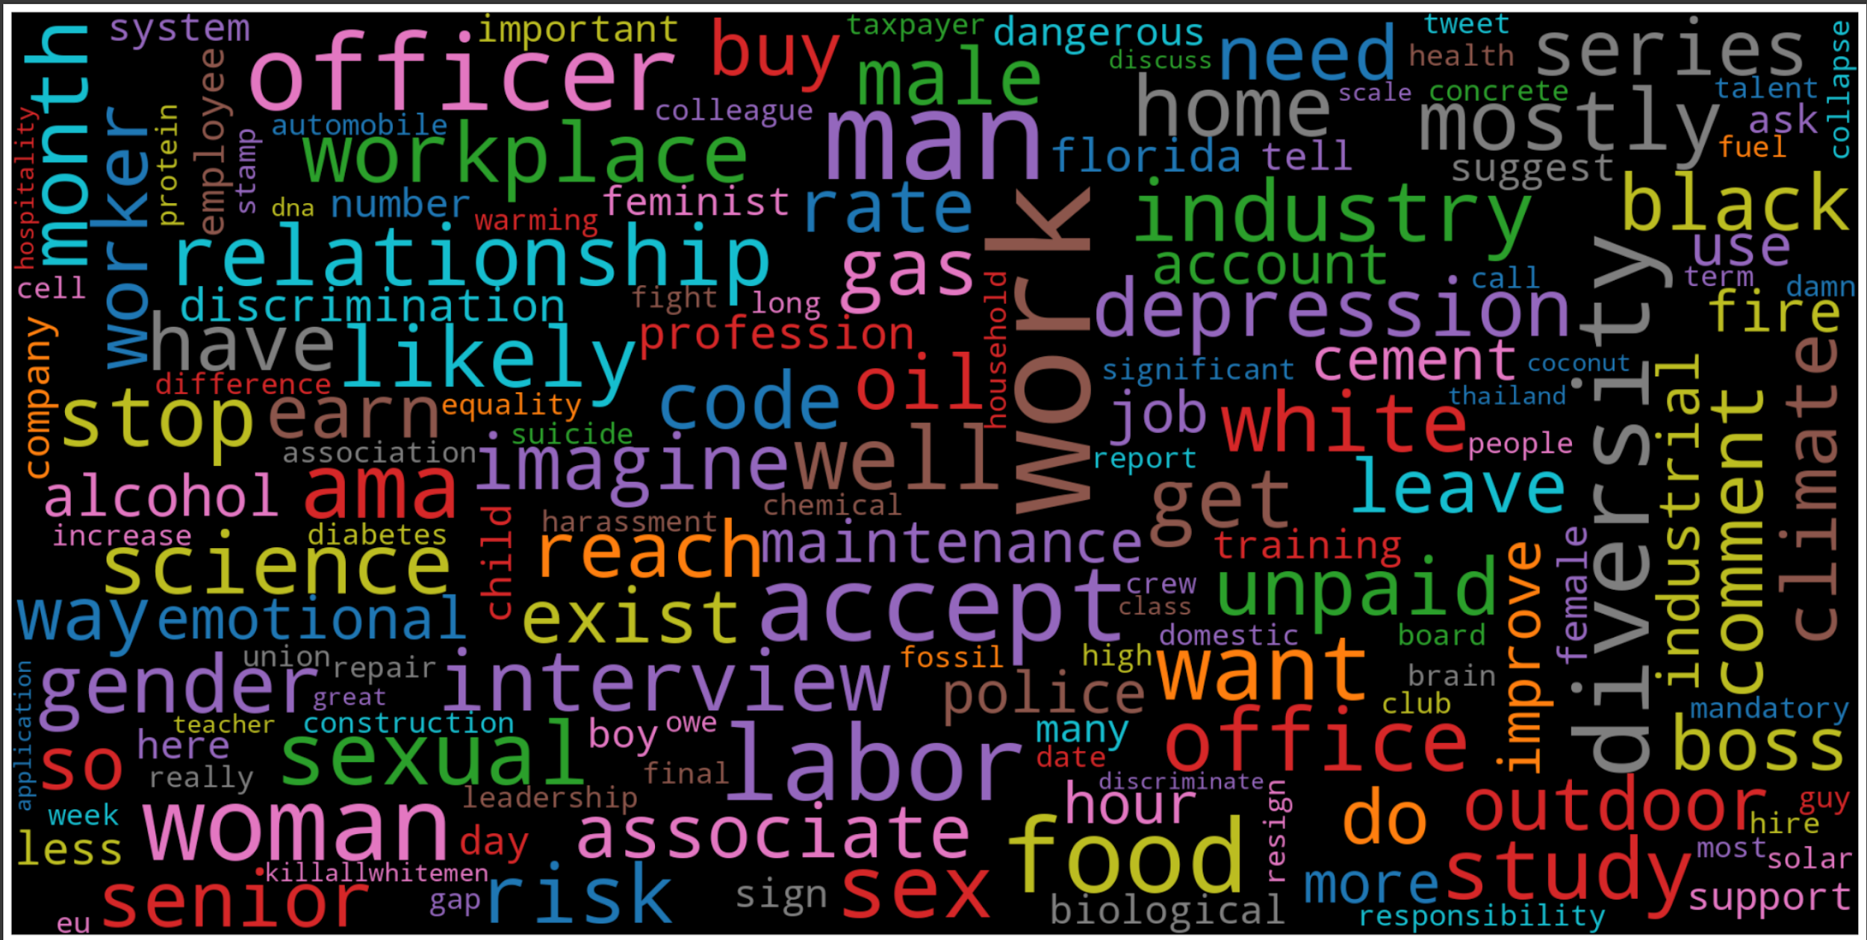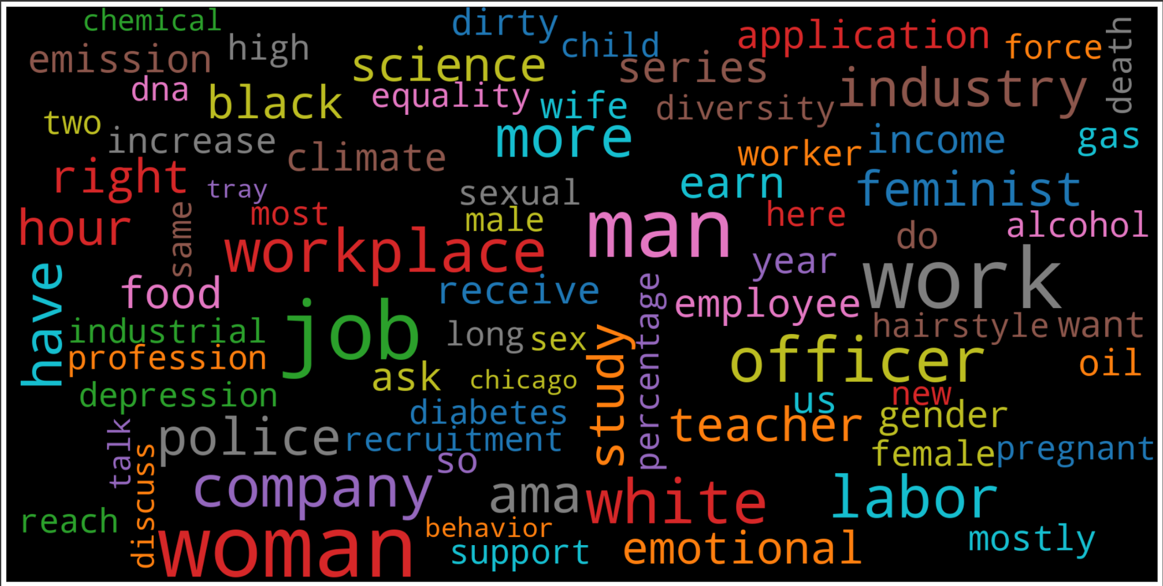

* 1. **Package 5:**

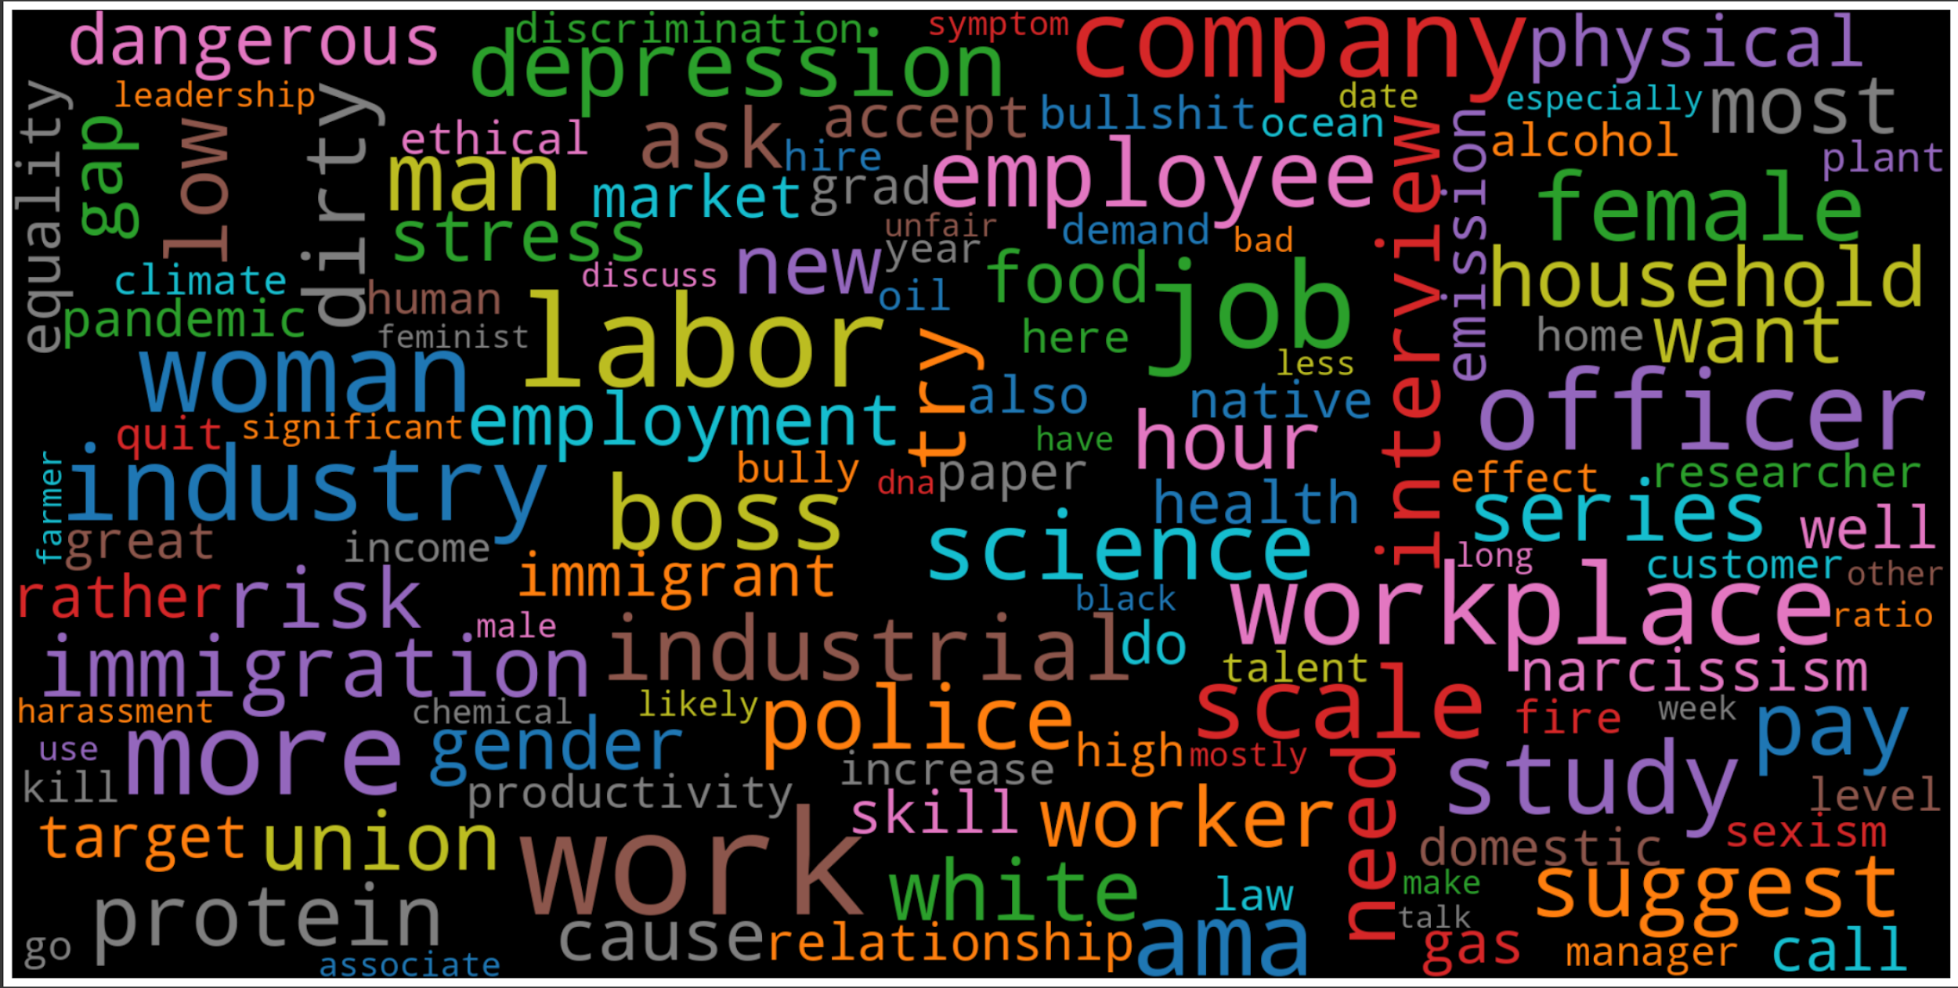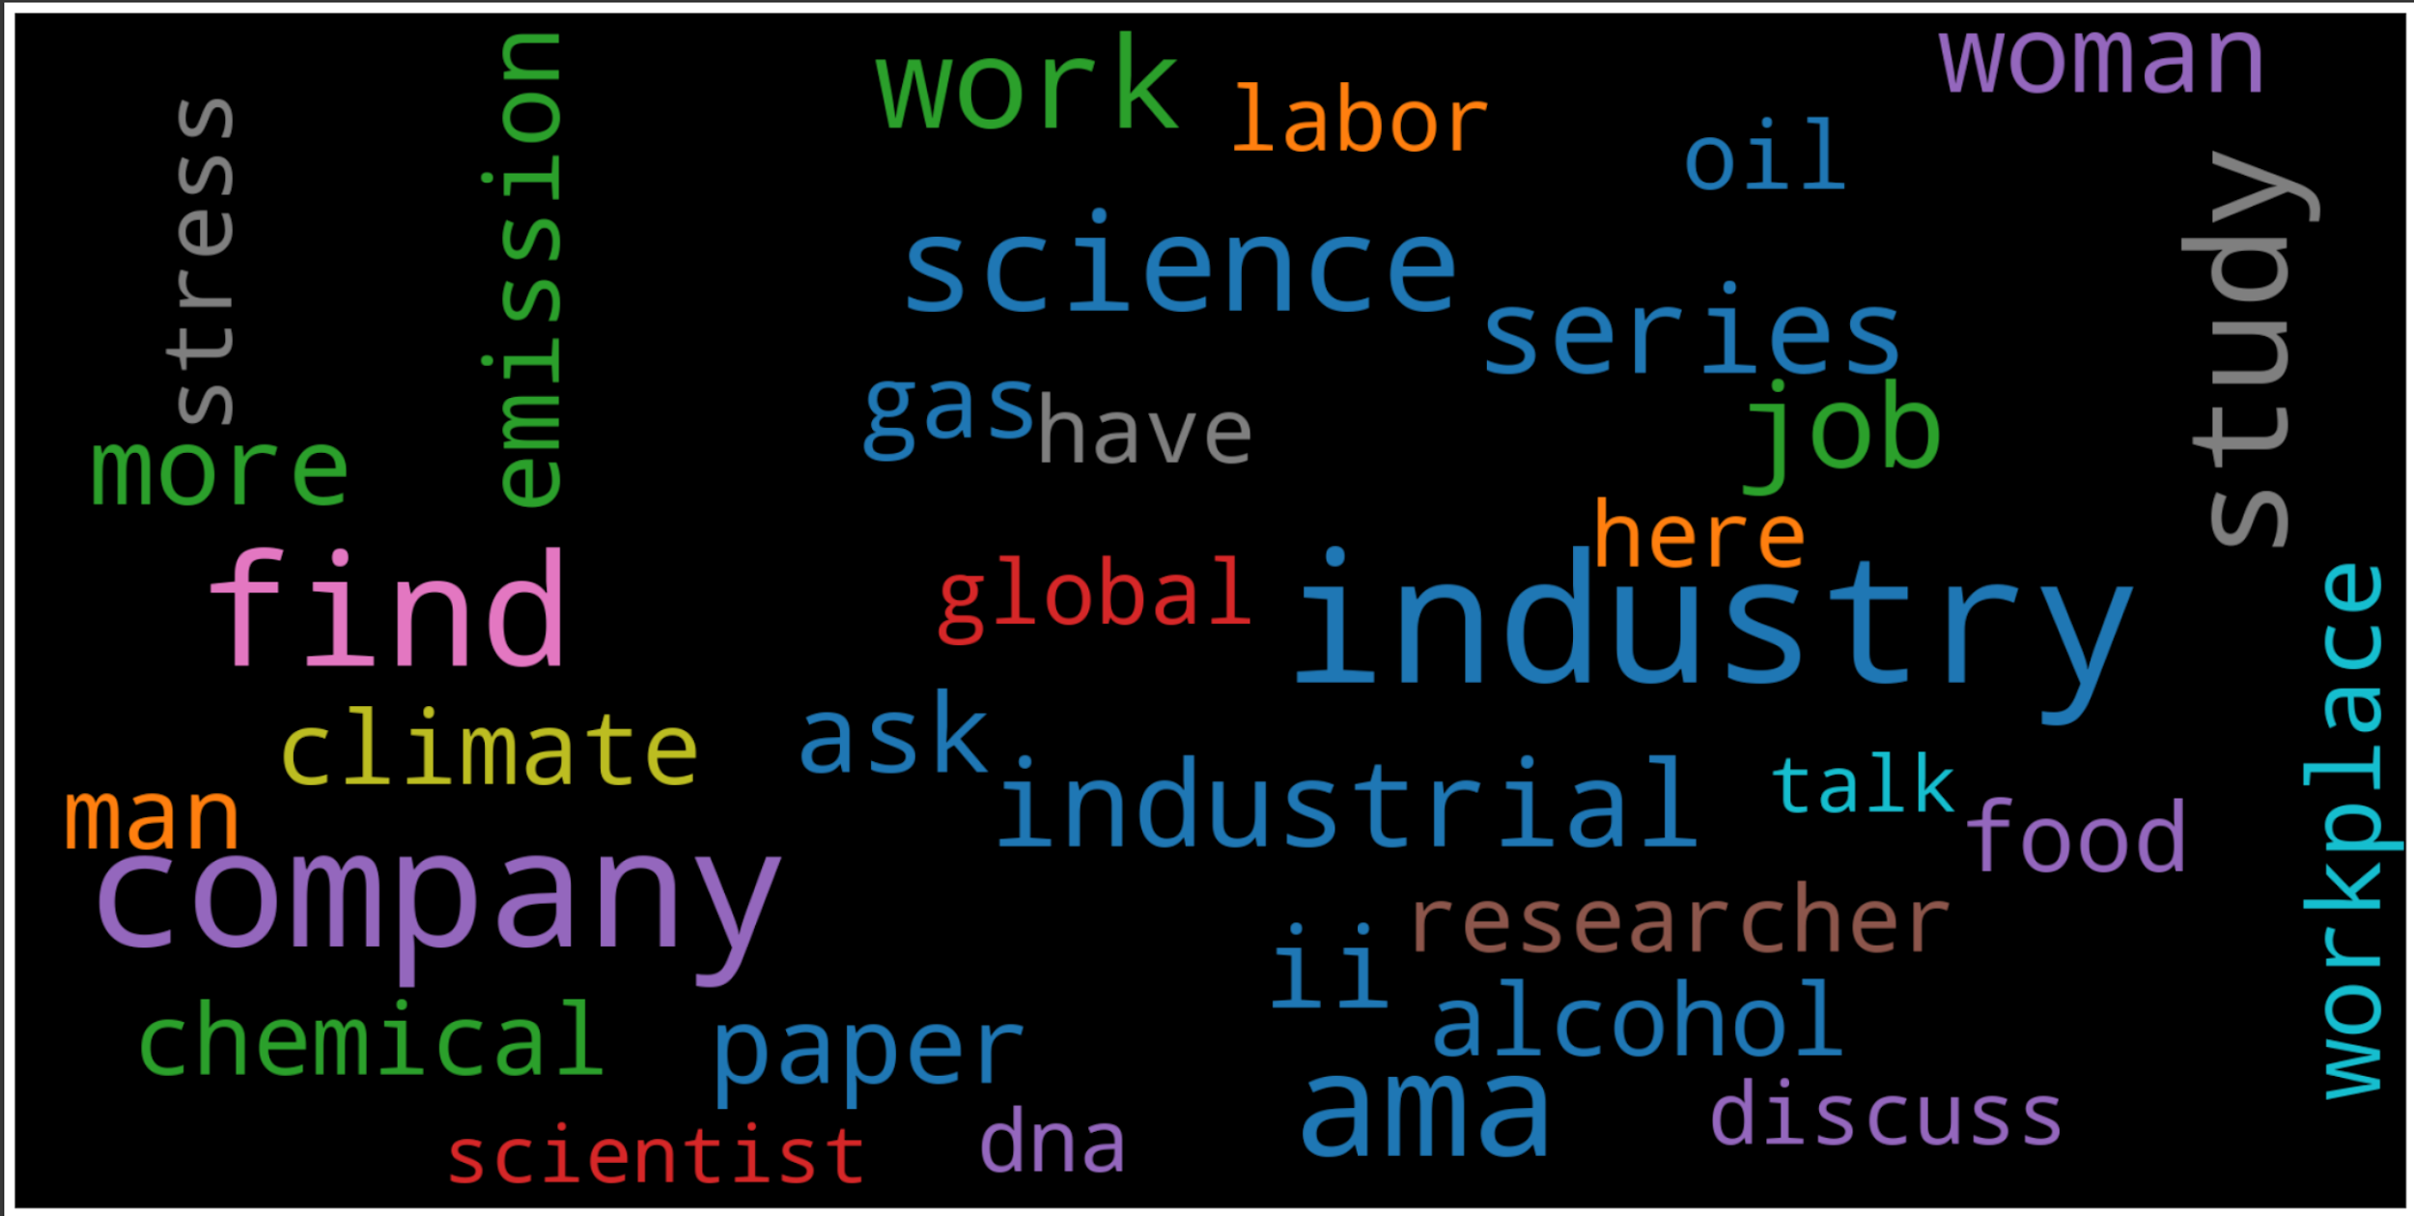

* 1. **Package 6:**

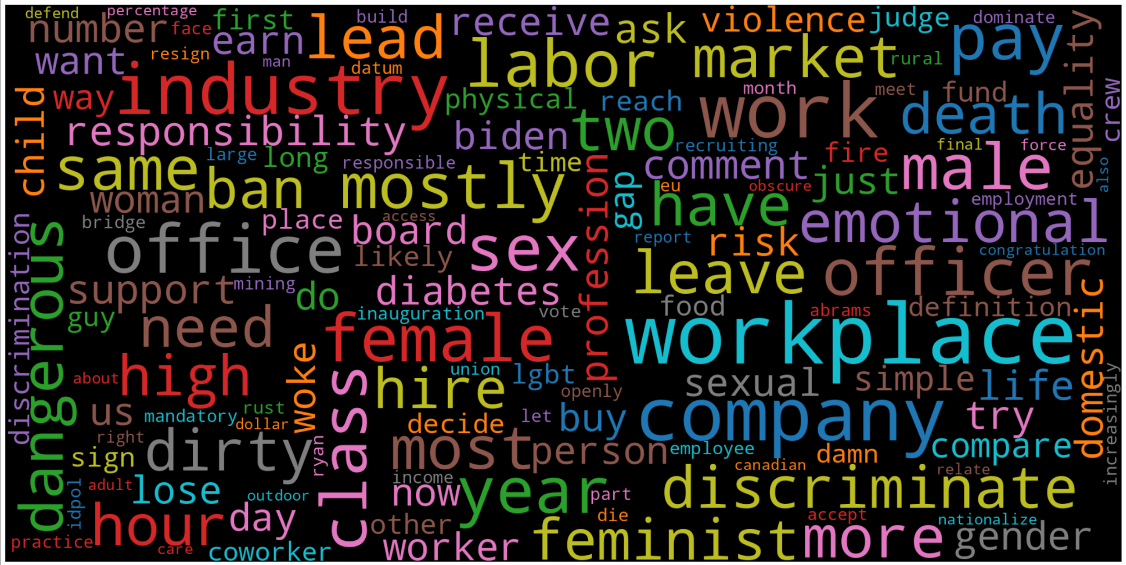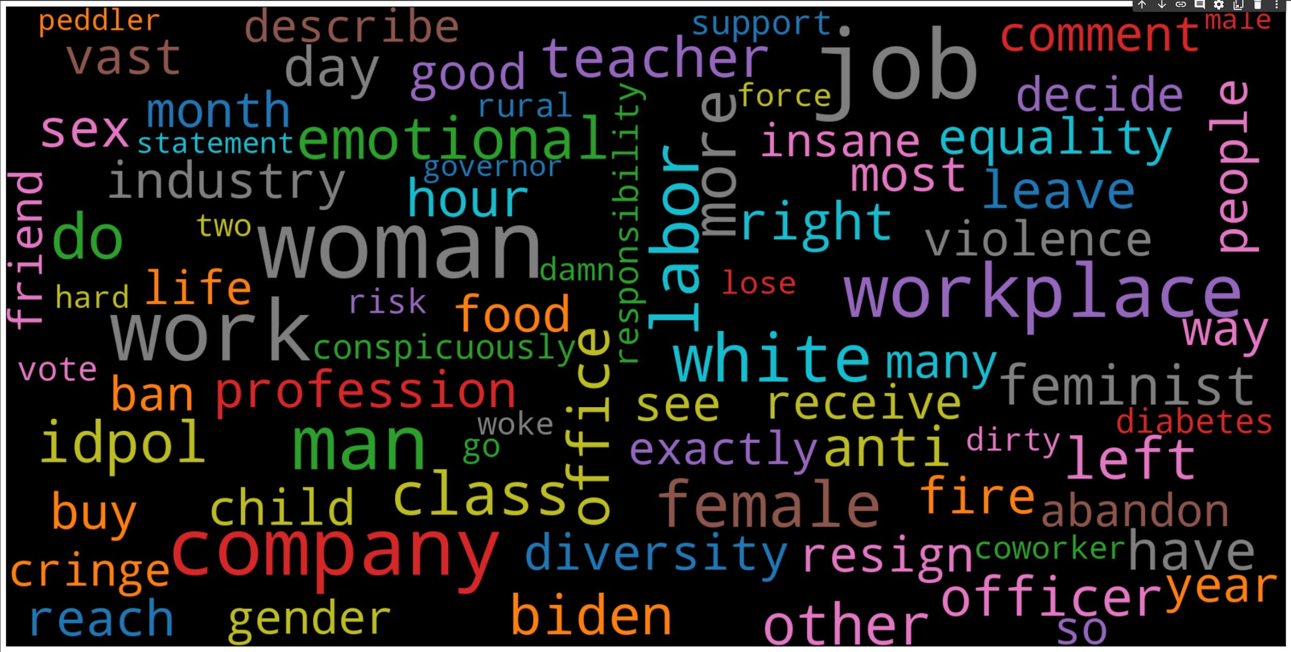

* 1. **Package 7:**

